Refunds in Cash Management:

In Cash Management, there is a procedure to refund money to a patron. It works very much like a transaction to sell an item.

On the Cash Management Wizard, click “Start New Transaction” from the bottom row of buttons:
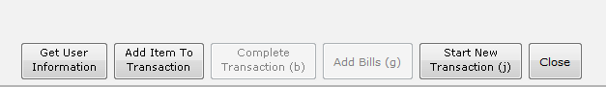

From the box that appears, choose “New Refund”:
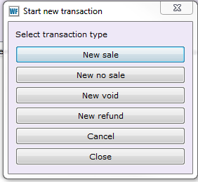

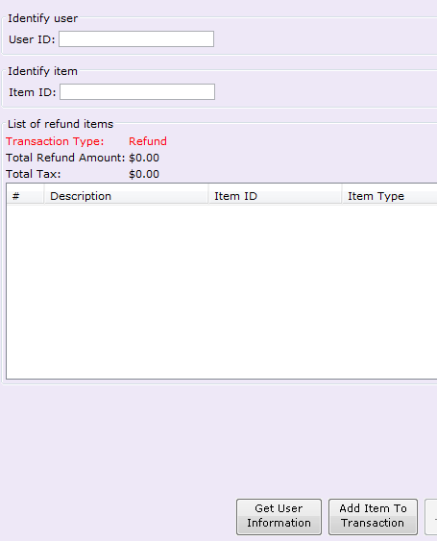
Note that “Transaction Type” is in red and says “Refund”.

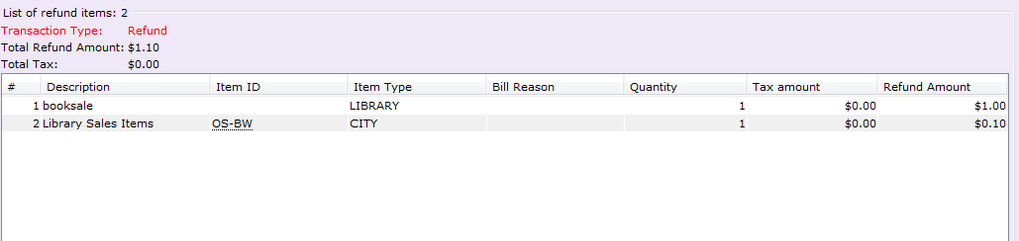
Enter the item ID, or use the Ad Hoc helper (blue shopping cart) to indicate what is being refunded, with the amounts.
FINES CANNOT BE REFUNDED THROUGH CASH MANAGEMENT. Use the Pay Bills Helper instead.

Click “Complete Transaction” at the bottom of the screen. The Payment box appears:
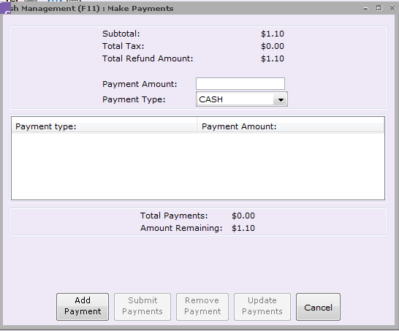

Enter “payments” for the refund as you would for a sales transaction, except using the Payment Type of CANCEL.
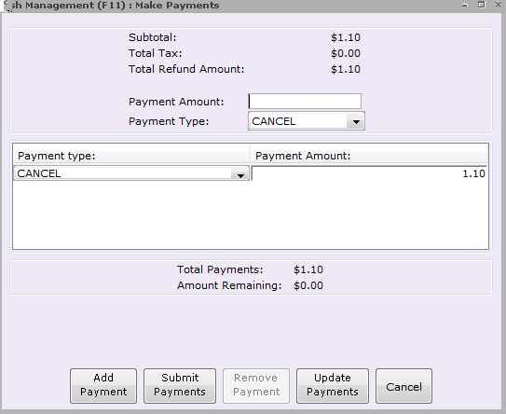

When finished entering “payments”, so that the Total Payments equals the “Total Refund Amount”, click “Submit Payments”.

A receipt prints, and the Transaction Completed box will appear, with options to start a new Sale, new No Sale, or new Refund:
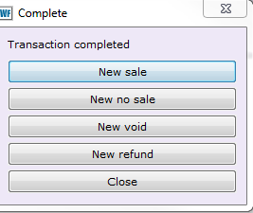

On the Till Summary Wizard, the refunds show as negative amounts, and with a Transaction Type of Refund and a Payment Type of CANCEL:
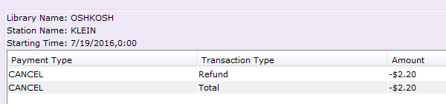

On the end of day spreadsheet report, lines for refund will show under the lines for particular library sales items, and lines for refunds done with Ad Hoc items will show above the total transaction amount; Refund amounts will be indicated in red text, with negative number formatting, and will be automatically subtracted from the totals.
There will also be a line for the payment type of CANCEL on the lower half of the spreadsheet.
